Assignment for Lecture 10
1. Develop the Complex class as the following specification in C++ and Java:
#ifndef COMPLEX_H
#define COMPLEX_H

class Complex {
private:
double real;
double imag;
public:
Complex(double real = 0.0, double imag = 0.0);
double getReal() const;
void setReal(double real);
double getImag() const;
void setImag(double imag);
void setValue(double real, double imag);
void print() const;
bool isReal() const;
bool isImaginary() const;
// Add the given Complex instance into this instance, and return this instance by reference
Complex & addInto(const Complex & another);
Complex & addInto(double real, double imag);
// Add the given Complex instance and this instance, return the sum in a new instance by value
Complex addReturnNew(const Complex & another) const;
Complex addReturnNew(double real, double imag) const;
};

#endif

2. Implement the class Date in C++ (Date.h, Date.cpp)/Java
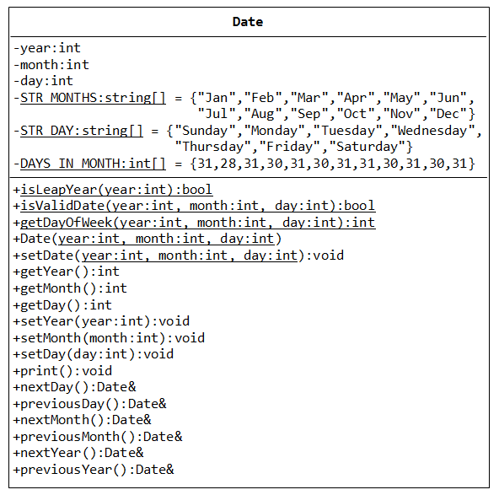
Then test the class (TestDate.cpp) in a program that create the dates Sunday, 1 Jan 2012, Tuesday, 31 Jan 2012, Monday, 31 Dec 2012 then display information about the next day. Display the previous day of 1/1/2012 and the day after one year of 29/02/2012
3. Programming Challenges (Tony Gaddis C++)
13.13

